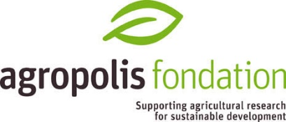

PROPOSAL DESCRIPTION

- Context & State of the art
5000 characters max. including spaces

- Objectives and outputs
4000 characters max. including spaces

- Strategy, Methodology, Approaches
5000 characters max. including spaces

- How will the proposed project mibilize competencies within and contribute in structuring the Labex Agro Community?
1000 characters max. including spaces

- Describe the training and/or capacity building component of the proposed project?
2500 characters max. including spaces

- Describe the visibility and partenership especially at the international level and the place of partnership in the South particularly in Africa
2500 characters max. including spaces

- Draft project organisation (work packages, tasks, scheduled starting date...)
5000 characters max. including spaces

- BIBLIOGRAPHY

